Saveetha school of engineering

Exp 3

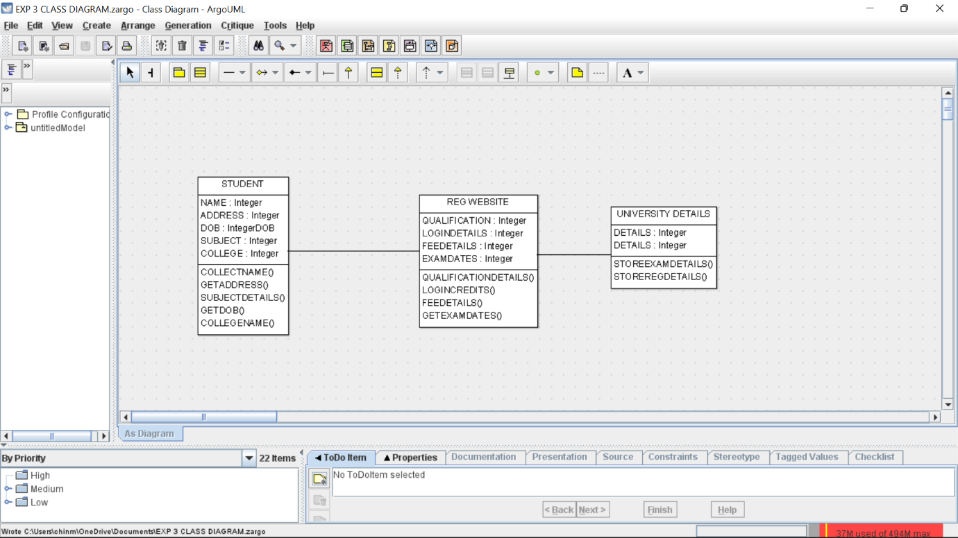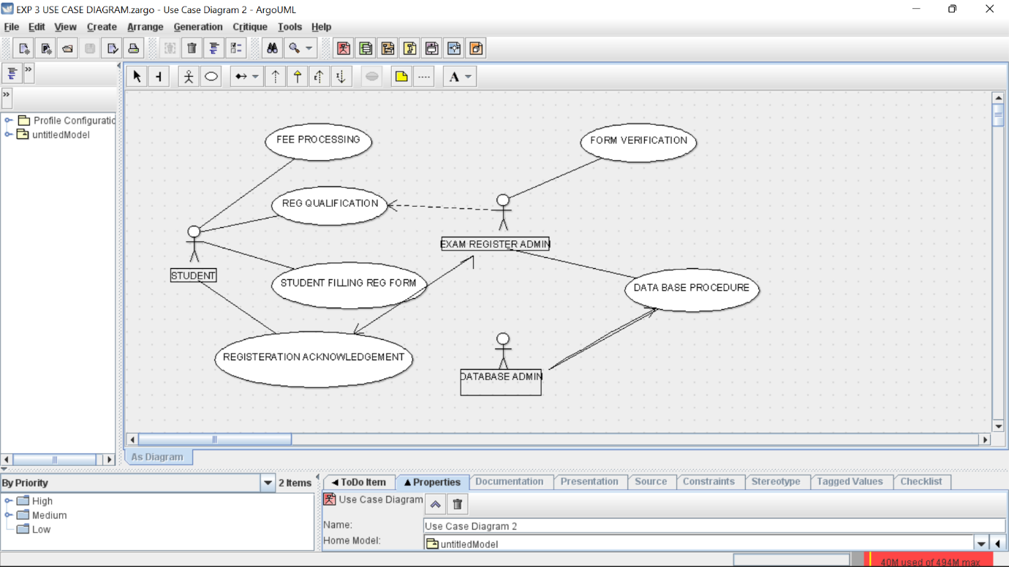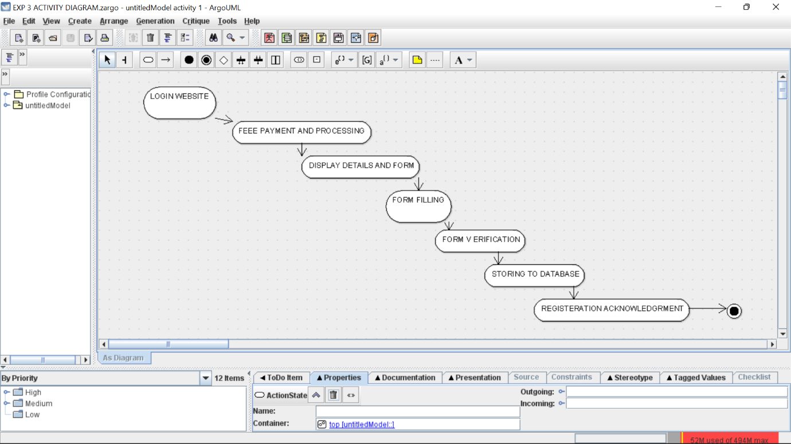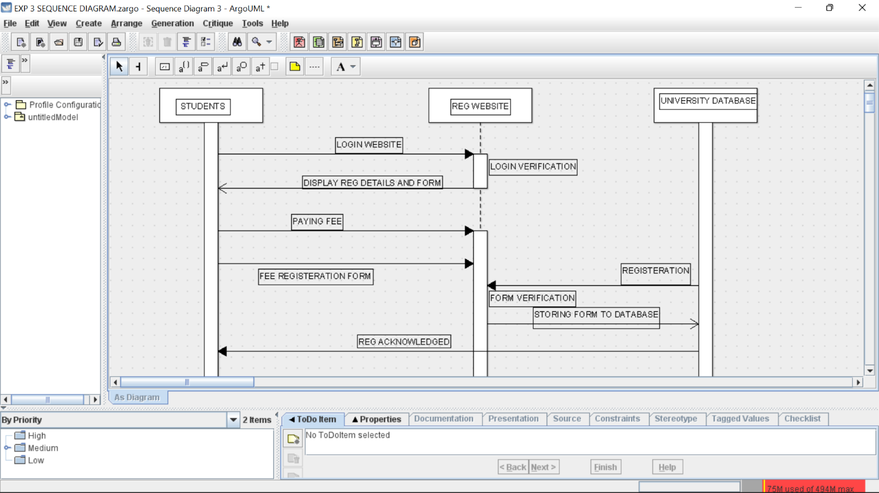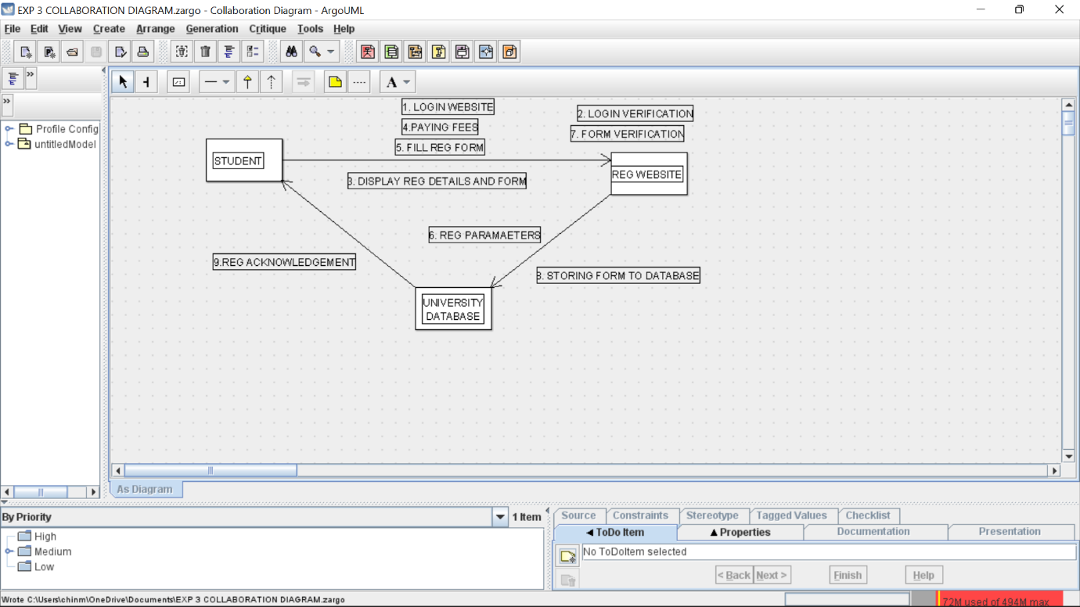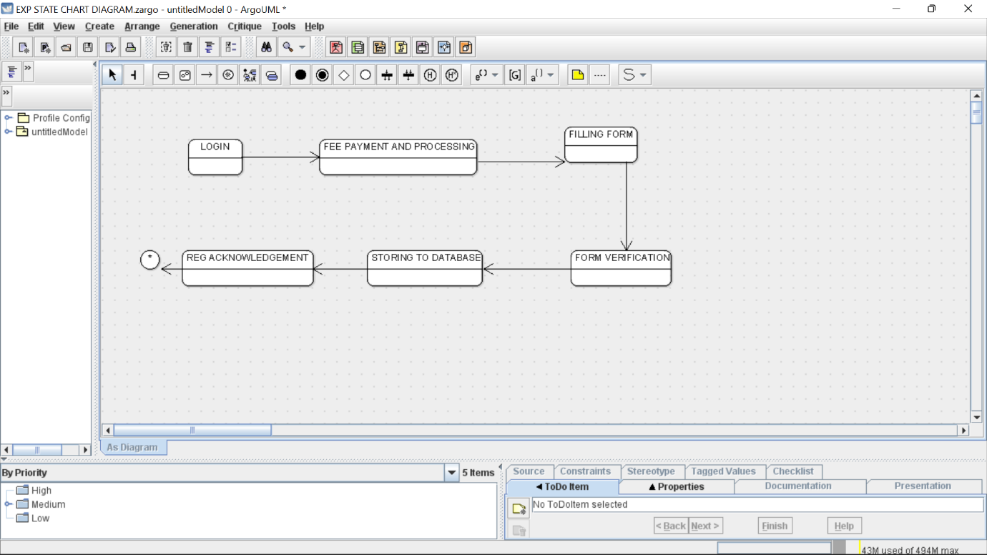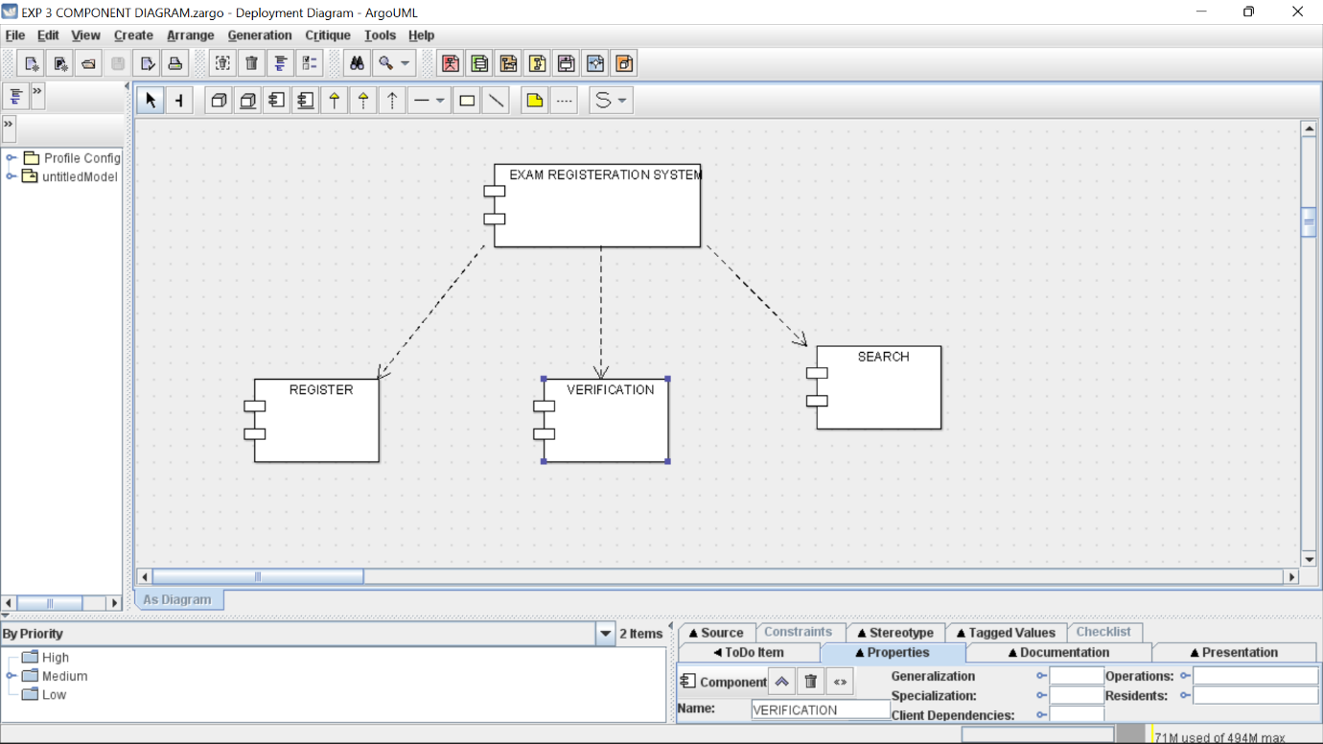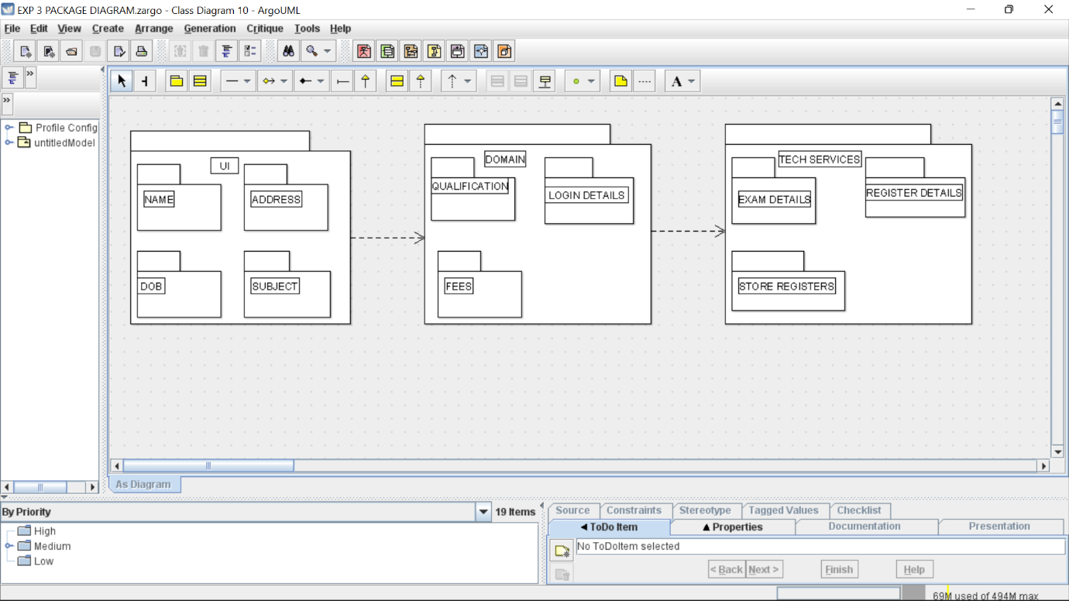

Skeleton diagram

import java.util.Vector;

public class REG WEBSITE {

public Integer QUALIFICATION;

private Integer LOGINDETAILS;

public Integer FEEDETAILS;

public Integer EXAMDATES;

public Vector mySTUDENT;

public Vector myUNIVERSITY DETAILS;

public void QUALIFICATIONDETAILS() {

}

public void LOGINCREDITS() {

}

public void FEEDETAILS() {

}

public void GETEXAMDATES() {

}

}

import java.util.Vector;

public class STUDENT {

public Integer NAME;

public Integer ADDRESS;

public IntegerDOB DOB;

public Integer SUBJECT;

public Integer COLLEGE;

public Vector myREG WEBSITE;

private void COLLECTNAME() {

}

public void GETADDRESS() {

}

public void SUBJECTDETAILS() {

}

public void GETDOB() {

}

public void COLLEGENAME() {

}

}

import java.util.Vector;

public class UNIVERSITY DETAILS {

private Integer DETAILS;

private Integer DETAILS;

public Vector myREG WEBSITE;

public void STOREEXAMDETAILS() {

}

public void STOREREGDETAILS() {

}

}